CSS GRID EX. 1
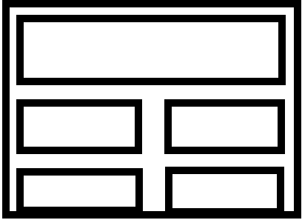
<div class=”grid-container”>
<div class=”first card”></div>
<div class=”card”></div>
<div class=”card”></div>
<div class=”card”></div>
</div>

.grid-container {
display: grid;
grid-template-columns: 1fr 1fr;
grid-template-rows: 100px 200px 200px;
gap: 30px;
}

.first {
grid-column: span 2;
}

.card {
background-color: blue;
}

